FESHM 5031.1 PIPING ENGINEERING NOTE FORM

Prepared by: Dustin Keller, Michael Sarychev Preparation Date: March 24, 2022

Piping System Title: E1039 – Backing Pipes

Lab Location: NM4 Lab Location code: FIMS 630

Purpose of system / system description:
This pipe relieves the target magnet Dewar under any form of over pressure situation, for example: quench or instantaneous vacuum loss.

Piping System ID Number (obtain from Teamcenter): EN05332

Appropriate governing piping code: ASME B31.3

Fluid Service Category (if B31.3): Normal fluid

Fluid Contents: Helium Gas

Design Pressure: 12 psig Design Temperature: -452F to 120F

Piping Materials: Stainless Steel Pipe and Flex hose

Drawing Numbers (PID’s, weldments, etc.): F10123326, 02928-01, -02, -03

Designer/Manufacturer: UVA & Fermilab / Meyer Tool Inc.

Leak Test Type: Hydrostatic, Pneumatic (circle one).

Reduced Test Pressure Qualification: In-Service, Low Stress, Not Applicable (circle one)

Test Pressure: 5 psig Test Fluid: Helium Test Date: TBD

A Helium Mass Spectrometer Leak Test was performed on December 30, 2020 to an 1x10-9 mbar-l/sec acceptance criteria. No leaks were detected. Report is attached below.

The flex hose section was pneumatically pressure tested to 100 psig and hydrostatically tested to 400 psig hydro.

Statement of Compliance

Is this piping system considered exceptional? Yes ____ No__X__
If “Yes”, follow the requirements for an Extended Engineering Note for Exceptional Piping Systems.

Reviewed by:
(Print Name and lab ID #)
Signature: Date: _____________
(If Teamcenter electronic Workflow approval is used instead of a physical signature note this in the signature blank)

D/S/P Head or Designee:
(Print Name and lab ID #)
Signature: Date: _____________
(If Teamcenter electronic Workflow approval is used instead of a physical signature note this in the signature blank)

The following approvals are required for exceptional piping systems:

Chief Safety Officer or Designee:
(Print Name and lab ID #)
Signature: Date: _____________
(If Teamcenter electronic Workflow approval is used instead of a physical signature note this in the signature blank)

Director or Designee:
(Print Name and lab ID #)
Signature: Date: _____________
(If Teamcenter electronic Workflow approval is used instead of a physical signature note this in the signature blank)

System Documentation

Process and instrumentation diagram appended? Yes / No

Process and instrumentation component list appended? Yes / No

Is an operating procedure necessary for safe operation? Yes / No
If ‘yes’, procedure must be appended.

Fabrication Quality Assurance

List vendor(s) for assemblies welded/brazed off site: Meyer Tool & Mfg., Inc. Documentation attached.

List welder(s) for assemblies welded/brazed in-house:
Fletcher, Thomas Austin

Are welder qualification records available for in-house welded/brazed assemblies? Yes / No
If yes, append documents or make available to reviewer.

Are all quality verification records required by the identified code available? Yes / No
(e.g. examiner's certification, inspector's certification, test records, etc.)
If yes, append documents or make available to reviewer.

Amendments

A new piping engineering note form must be filled out and the applicable approvals obtained for piping engineering note amendments.

Diagram & picture of manifold covered by this engineering note:

The red highlighted line shown depicts the manifold covered in this engineering note within the assembly.
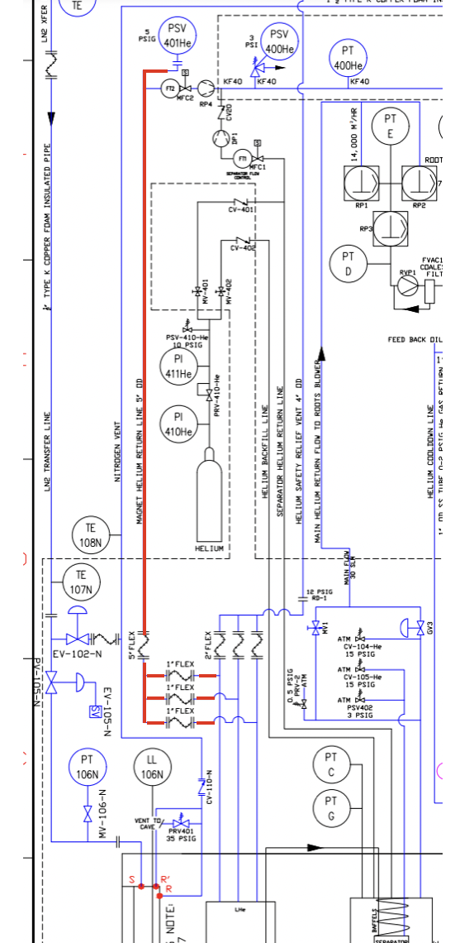

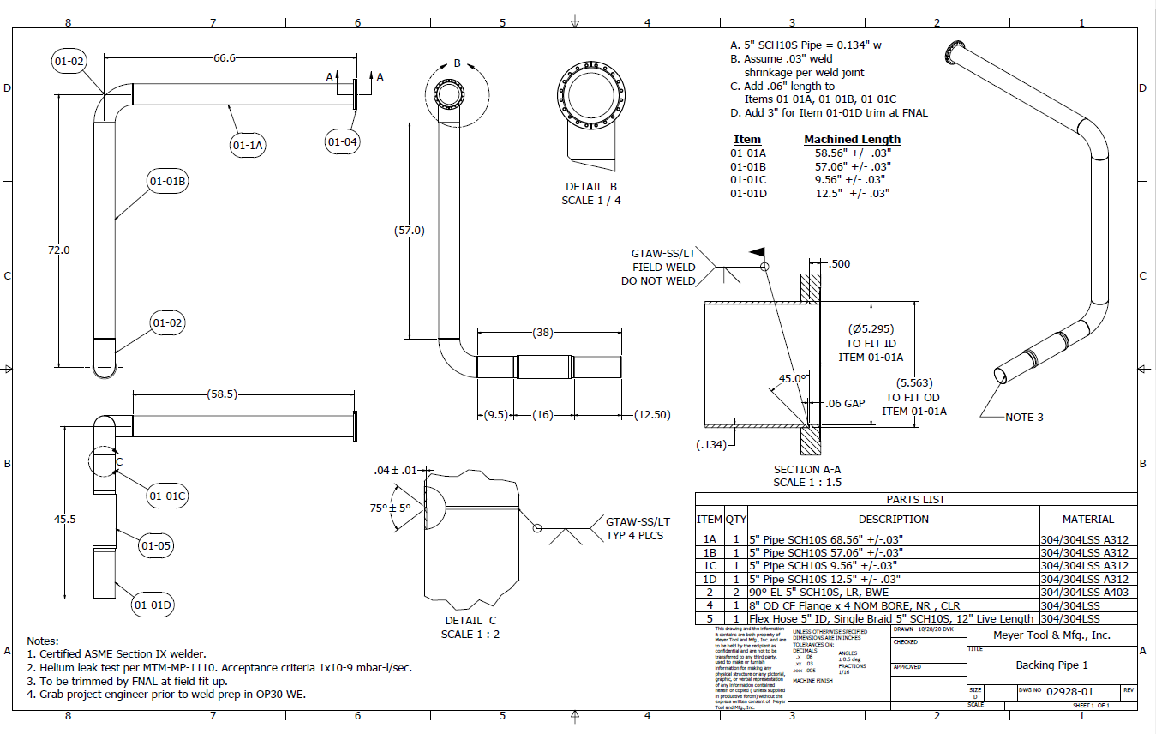
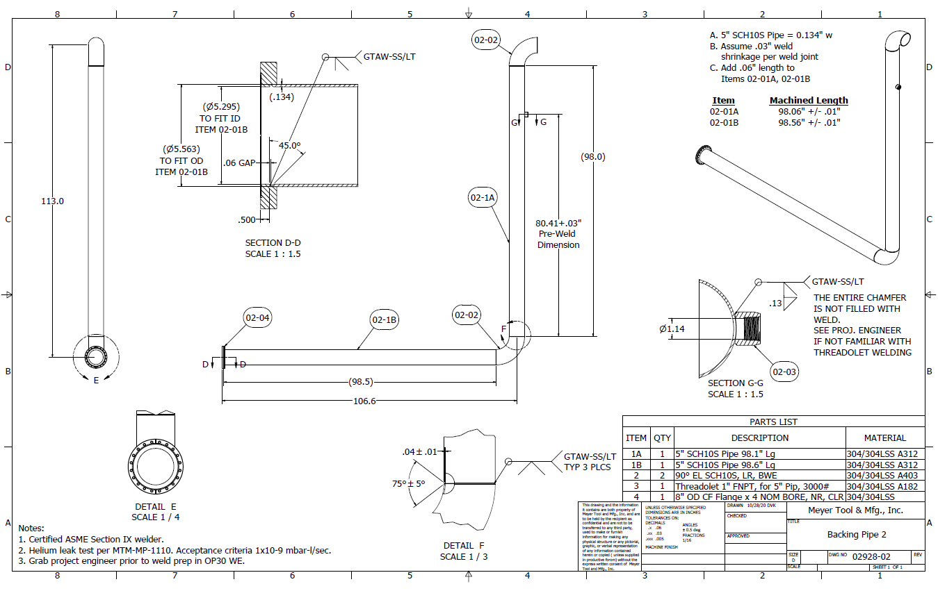

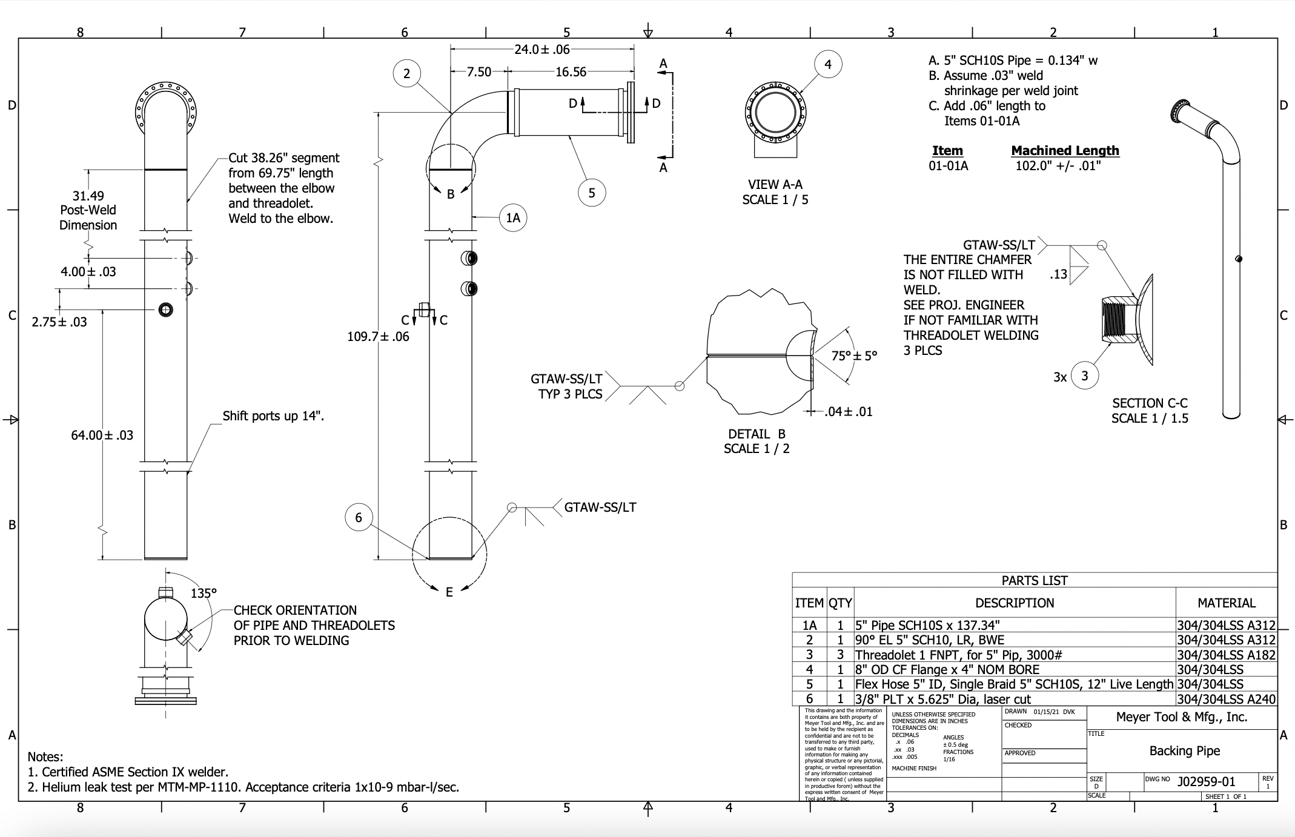
The Conflat flange and pipe welds were welded by FNAL welder Austin Fletcher. These welds took place as per the method given in ED0004253 and qualify built as per ASME B31.3.

List of components used within this manifold:

Inforation on 5” flex hoses:

Cuffs: 304/304LSS 5"" SCH10S x 2" LG Cuffs
Live Length: 12" Overall Length 16"" +/-.06"
Max. rated working pressure @ 70 F: 100 PSI
Full internal vacuum Welding per ASME B31.3, ASME Section IX qualified welders only
Helium Leak Tested: Acceptance criteria 1x10-9 mbar-l/sec
Full Name | Type | Fluid | Rating | Manufacturer | Size ID
PSV-401 | PSV | He | 100 psig | FNAL | 4”
5” pipe | Pipe | He | 100 psig | Meyer | 5”
5”Flex Hose | Flex Hose (401M) | He | 100 psig | Meyer | 5”
5" Flex Hose | Flex Hose (401M) | He | 100 psig | Meyer | 5”
QF40-150-SRV | Fitting | He | 4251 psig | Kurt J. Lesker | 1.57”
P103107 | Adapter | He | 290 psig | IdealVac | 1.57”
5793K15 | Flex Hose | He | 710 psig | McMaster-Carr | 1.57”
4464K157 | Bushing | He | 150 psig | McMaster-Carr | 1.57”
2698K19 | Pipe fitting | He | 150 psig | McMaster-Carr | 1”
P101604 | Adapter | He | 290 psig | IdealVac | 1”
P101605 | Adapter | He | 290 psig | IdealVac | 1”
2698K18 | Tee connector | He | 150 psig | McMaster-Carr | 1.57”
2698K18 | Tee connector | He | 150 psig | McMaster-Carr | 1.57”
P101969 | Adapter | He | 290 psig | IdealVac | 1”
5793K15 | Adapter | He | 150 psig | McMaster-Carr | 1”
Pressure Test per ASME B31.3
Test Reports and COC Required
No Charpy Impact Tests required

Flex Hoses and pipe support per EJMA section 2 guidelines and in regards to the stress analysis. Pressure test and inspection complete both by Meyer and FNAL.

- Description and design approach:

This relief pipe is designed to relieve the target magnet Dewar under any form of over pressure, for example, quench or instantaneous vacuum loss. This is an operational relief line (not safety), normally operating at slightly sub-atmospheric conditions, preventing bursting of a 12 psig rupture disk RD1 that protect the magnet LHe volume (ref. TC EN05273). This quench line is directly connected to this volume, and RD1 is the safety protection for both (reference to P&ID). The Fermilab made, 4” parallel plate relief, set at 5 psig, will open, should the line pressure go above this threshold. In case of failure, the rupture disc will protect the line.
Though not anticipated, because this pipe connects directly to a tank containing liquid Helium - there is possibility of cryogenic fluid entering this pipe. This could happen in the event of a tank overfill caused by failure of the liquid level indicator, control system, or a control valve, for example. The piping used in the design is rated to handle the possibility of cryogenic fluid.

The flex hose sections on the piping were added for ease of integration with the system as well as additional strain relief on the piping. The flex hoses were pneumatically leak tested to 100 psig.

The same type of flex hoses have been approved in EN07152 and EN05273 and are being used in other parts of the E1039 target system.

- Design Codes and Calculations

The system was designed and fabricated in compliance with ASME B31.3 as a 100 psig design pressure piping, however will be used as a low-pressure helium system that operates just below atmospheric pressure. All components that feed this manifold are relieved at 5 psig as an operational relief and at 12 psig as a ASME coded safety relief

Design verification, flexibility analysis and manufacturer’s data are attached.

- Materials:

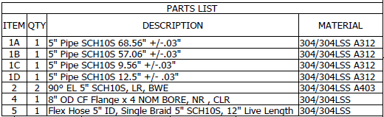

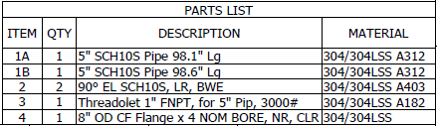
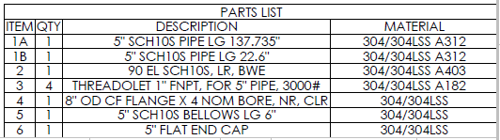

Additional materials sheets attached below.

- Welding:
Most of the welding was completed by Meyer Tool & Mfg., Inc. by a certified ASME section IX welder. All welding performed according to welding procedure GTAW-SS/LT.
Welding of manufactured piping sections in place was performed by ASME certified Fermilab welders.

Welding Procedure Specification, Welder Performance Qualification, and Visual Examination Report are attached.

Low Stress Piping Evaluation

Here we evaluate the piping under the requirements given in FESHM 5031.1-3 (fluid service, basic allowable stress, fitting pressure rating, etc.). If all the requirements are met the pipe is considered low-stress pipe. The leak test of low-stress piping outlined in Section 5 of FESHM 5031will be performed and documented to satisfy this requirement.

Low Stress Piping
A piping system in normal fluid service which adheres to the filling criteria:
- The design gage pressure is less that 150 psig (1.035 MPa): The design gauge pressure is 12 psig.
- The calculated stress due to pressure per American Society of Mechanical Engineers (ASME) B31.3 paragraph 304 is less than 20% of the basic allowable dress listed in ASME B31.2 Table A-1: See calculation below. This calculation indicates that the actual stress (0.31 ksi) is much less than 20% of the allowable stress (3.34 ksi).
- All fittings are pressurized to less that 20% of their rated pressure: The lowest pressure rating for all fitting, clamps, hoses, etc, is 100 psig. All will be used well below 20 psi.
- The maximum design temperature is less that 366 °F (186 °C): The design temperature is room temperature so far below 366 °F (186 °C).
- All materials are ASME code listed for the range of design temperatures: Yes all materials are ASME code listed for the range of design temperatures.
- The fluid handled is nonflammable, nontoxic, and except for effects of temperature, not damaging to hum tissue: Yes, the fluid in this case would be helium which is nonflammable, nontoxic and not damaging outside of the low temperature consideration.

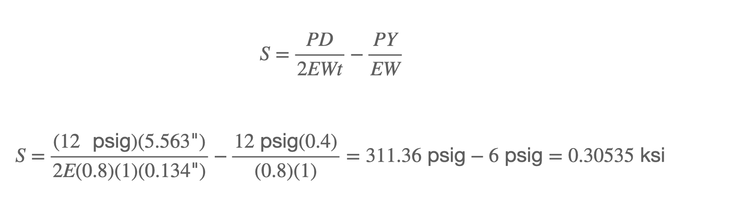
For 5” sch 10S 304L/A312 SS pipe, per ASME B31.1:

